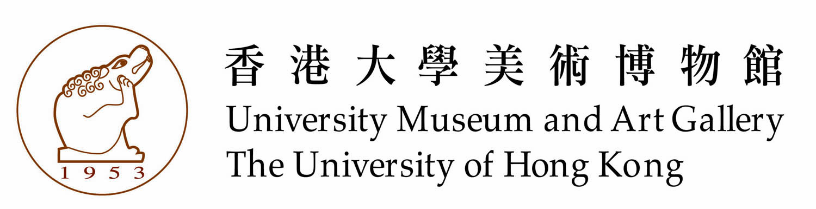

About University Museum and Art Gallery of the University of Hong Kong
The University Museum and Art Gallery (UMAG) of the University of Hong Kong was founded in 1953 as the Fung Ping Shan Museum. Originally established as the Fung Ping Shan Library of Chinese language publications in 1932 in honour of its benefactor, the building continues to run as a museum after the Fung Ping Shan library relocated into the University main library building in 1961. The museum was renamed the UMAG in 1994 shortly before its new wing was opened to the public in 1996. It is the oldest continuously-operated museum in Hong Kong and has over the past sixty years built up a diverse collection of ceramics and bronzes dating from the Neolithic period (c. 7000-c. 2100 BC) to the Qing dynasty (1644–1911), as well as traditional and modern paintings from the Ming dynasty (1368-1644) to the twenty-first century.
Chief among the collections are the Museum's ceramics, which show the extraordinary achievements of Chinese potters from Neolithic period painted pottery jars, to the decorative porcelains of the Qing dynasty. Among the early wares are examples of funerary vessels dating from the Han (206 BC–AD 220) to the Tang dynasties (618–907) that include lead-glazed models and objects, as well as tri-coloured (sancai) ceramics. Throughout Chinese history, ceramics have been traded and admired outside China. Of these, greenwares, particularly Yue and celadon wares, which were sought after in Southeast Asia and Korea, and the development of blue-and-white porcelains, which were made for the Islamic market and popular in Europe, have been the most influential and are well-represented in the Museum's collection. Of particular note is one of the earliest known examples of underglaze-blue decoration in the form of a small tripod water pot dating to the Tang dynasty. The Museum also has representative examples of wares made by the famous Song (960-1279) kilns such as those of Ding and Cizhou, and mono- and polychrome decorated wares of the Ming and Qing dynasties.
Other highlights of the collection are the Museum's Chinese bronzes that include ritual vessels dating to the Shang (c. 1600–c. 1100 BC) and Western Zhou (c.1100–771 BC) periods, and a comprehensive collection of mirrors dating from the Eastern Zhou (770–256 BC) period to the Tang dynasty. The Museum also contains the largest known collection of Mongol period (Yuan dynasty 1271–1368) Nestorian crosses in the world. In addition to its collection of carvings in wood and stone, the Museum also has a small but significant collection of Chinese ink painting dating from the Ming dynasty to the present, and twentieth-century Chinese oil painting.
In addition to these permanent collections, the UMAG regularly hosts exhibitions of contemporary and ancient Chinese and Western art and history. The Museum was originally established as a teaching museum and has maintained this commitment to the University to this day through the teaching of Chinese art and museum studies and by encouraging students and school pupils to broaden their education through the arts. It also regularly presents non-exhibition related talks and activities that are open to both the University's students and the public. The Museum also endeavours to promote knowledge of Chinese tea culture through its Tea Gallery, which is also open to public.
UMAG is located next the East Gate of HKU as well as the first three floors of the T.T. Tsui Building. The opening time is Monday to Saturday at 9:00am to 6:30pm; Sunday at 1:00pm to 6:00pm. Closed on university and public holidays.
Membership of The University of Hong Kong Museum Society is open to anyone with an interest in the arts. Members benefit from a wide variety of specially-organised educational events, and visits to museums, galleries and other places of interest. Members also have the opportunity to take part in overseas visits to sites of special cultural interest. All proceeds from the Society go directly to support the Museum and its activities.

有關香港大學美術博物館

香港大學美術博物館原稱為馮平山博物館，創立於一九五三年，前身原為香港大學馮平山圖書館，一九三二年馮平山樓落成後正式成立，圖書收藏以中文文獻為主，兩者皆以捐建人名義冠名。一九六一年，馮平山圖書館遷至大學圖書館總館後，馮平山樓才正式作為博物館用途。一九九四年，博物館再易名為香港大學美術博物館，並於一九九六年增建新翼徐展堂樓。過去六十年來，作為香港現存歷史最悠久的博物館，博物館庋藏許多中國文物與藝術品，其中青銅與陶瓷館藏可由清代(一六四四年至一九一一年)上溯至新石器時代(約公元前七零零零年至公元前二一零零年)，而書畫館藏則介於明代 (一三六八年至一六四四年) 與二十一世紀之間。

館藏以陶瓷最受矚目，當中包括漢代(公元前二零六年至二二零年)鉛釉陶器及唐代(六一八年至九零七年)三彩器等早期器皿。基於瓷器一直是中國對外經貿的主要商品，其中尤以越瓷及青瓷備受東南亞及韓國人士青睞。至於曾為迎合中東及歐洲市場於中國發展而成的青花瓷器，亦有代表作品見於館藏，當中尤以唐青花三足水盂最為人津津樂道。另外其它重要館藏還包括定窯、磁州窯等宋代 (九六零年至一二七九年)瓷器，以及明清兩代的單色釉和彩瓷。

另一批館藏珍品，則有商代(約公元前一六零零年至約公元前一一零零年)和西周 (約公元前一一零零年至七七一年)的青銅禮器，以及一批東周 (公元前七七零年至公元前二五六年)至宋代的銅鏡。而館內的元代(一二七一年至一三六八年)景教十字銅牌收藏量更是世界之冠。除此之外，館藏還有一小部份的玉石木雕、明代以降的水墨畫及當代中國油畫。

除展出館藏外，博物館也經常舉辦古今中外各類藝術展覽，並為校內學生及公眾舉行研討會、講座及其他活動。博物館同時參與香港大學藝術系的教學工作，教授中國藝術及博物館學等課程，秉承大學博物館以教育為目標的宗旨，希望透過藝術教學開拓學生視野。此外，為推廣中國茶文化，館內設有“博寮茶座”供參觀人士休憩品茗。

博物館座落於般咸道大學入口旁的馮平山樓及徐展堂樓底下三層。開放時間為星期一至星期六，上午九時三十分至下午六時；星期日，下午一時至六時。大學及公眾假期休息。

香港大學博物館學會是獨立的文化團體，經常資助博物館去推廣文物藝術欣賞的工作。學會每年舉辦不同類型活動，例如組織會員參觀各地博物館和名勝古蹟，以及主辦專題講座。各界人士均可參加入會。

